Lab 9
Introduction:
CPU scheduling is a fundamental function of an operating system that determines the order in which processes access the CPU. Since multiple processes compete for processor time, a scheduling algorithm improves system responsiveness, utilization, and fairness. In this exercise, three scheduling algorithms were implemented and tested:
- First-Come, First-Served (FCFS) – Non-preemptive, order based on arrival time.
- Priority Scheduling (Non-Preemptive) – Chooses the process with the highest priority (lowest number = highest priority).
- Round Robin (RR) – Preemptive time-shared scheduling with a fixed time quantum.
The purpose of this task is to compare these schedulers based on waiting time and turnaround time.
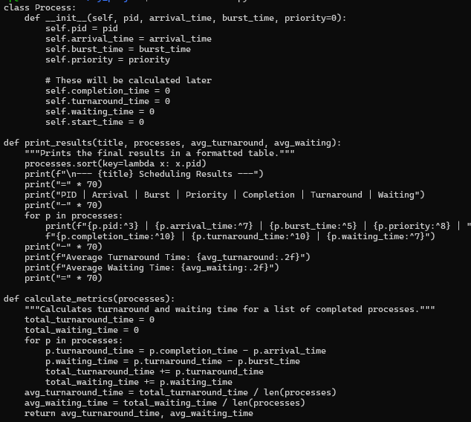
Priority Scheduling:
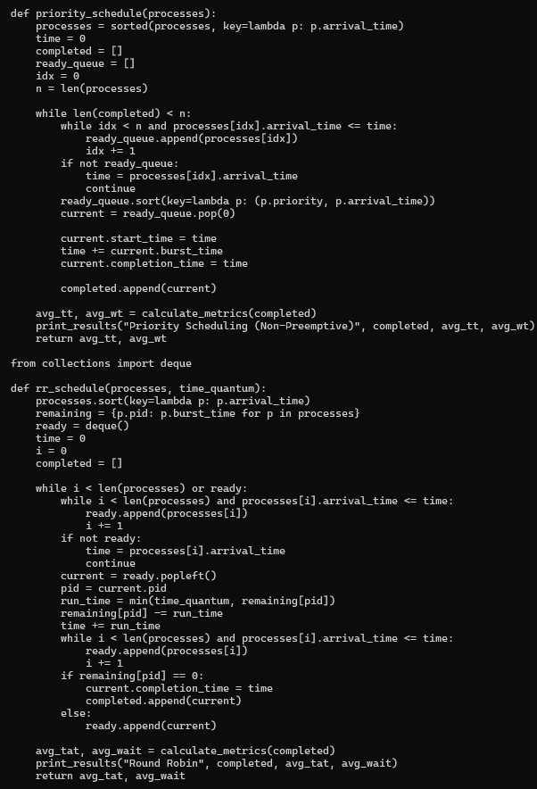
Round Robin (RR):
First-Come, First-Served (FCFS):
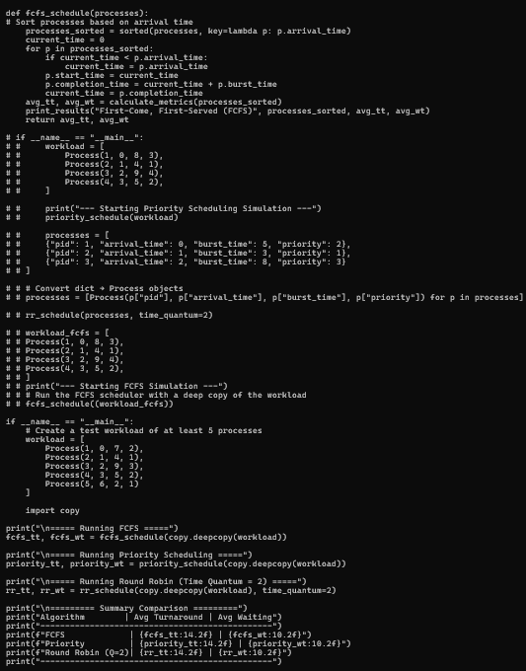
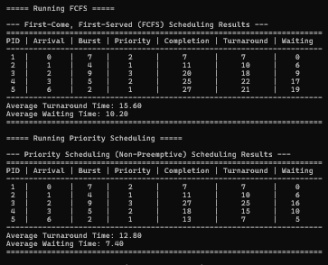
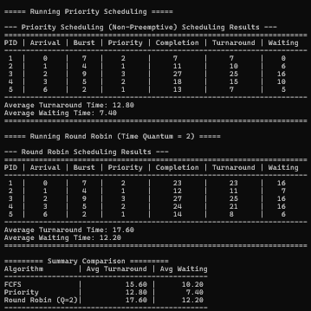
Which scheduler performed best?
The Priority Scheduling algorithm performed the best for this workload.
It achieved the lowest average waiting time (7.40) and lowest turnaround time (12.80) because it always executes the highest-priority (lowest-numbered) process next, reducing delays for short and important processes.
Why choose Round Robin even with higher waiting time?
Round Robin is preferred in time-sharing and interactive systems, where fairness and responsiveness are more important than average waiting time.
Even if waiting time is higher, RR ensures:
- Every process gets CPU time regularly
- No starvation
- Better user experience in multitasking systems
This makes RR ideal for operating systems used by multiple active users.
Drawback of Priority Scheduling
The main drawback is starvation.
Lower-priority processes may never get CPU time if higher-priority ones keep arriving.
A long process with low priority may stay in the ready queue indefinitely.
Conclusion
This experiment demonstrated how different scheduling algorithms affect process completion time.
Priority Scheduling gave the best performance for the given workload, while FCFS produced moderate results but suffered from long waiting times for later processes. Round Robin ensured fairness but had the highest waiting and turnaround times due to frequent context switching.
Choosing a scheduler depends on the system's goals—whether fairness, response time, or overall throughput is more important.

